I like: | Which toppings do you like?
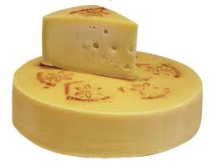
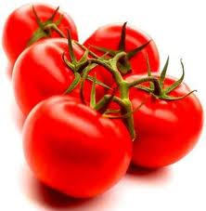

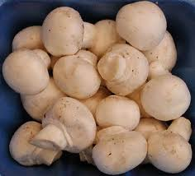
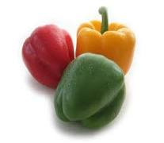
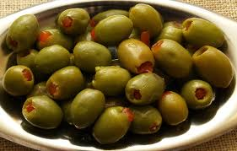
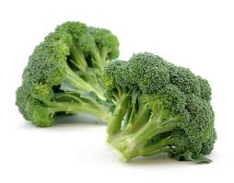
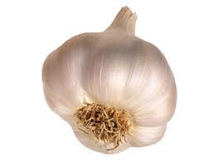
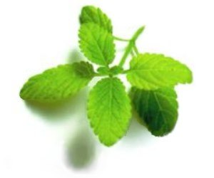

 |  | 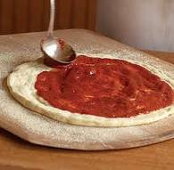
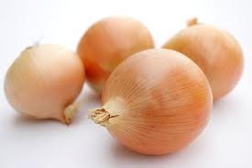
 |  | dough | tomatoes
 |  | oregano | mushrooms
 |  | olives | peppers
 |  | broccoli | onions
 |  | garlic | extra cheese
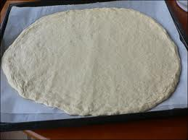 |  | 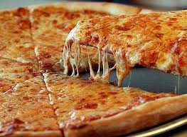 | pizza
 |  |  | pizza

 | peppers | oregano | sauce | pizza | onions | broccoli | cheese | dough | tomatoes | extra | olives | garlic
garlic
onions
peppers
oregano
olives
dough
broccoli
pizza
extra
cheese
sauce
tomatoes

I am a pizza

I am a pizza
With extra cheese
From tomatoes
Sauce is squeezed
Onions and mushrooms
Oregano
I am a pizza, ready to go

I am a pizza
Peppers green
Olives and mushrooms
Onions are seen
I am a pizza
Order by phone
I am a pizza, please take me home

I am a pizza
Into through town
Driving quickly and
And upside down
I was a pizza
I was the best
I was a pizza
Now I’m a mess!

