5 Everyday Things You Never Knew Had Names
There are so many things out there that we deal with or see everyday, but have no idea what they are called. This is a list of 25 ridiculous real names for 25 everyday items.posted about a year ago
2K
- 1. Tittle

The dot over an 'i' or 'j.'
- 2. Lunule
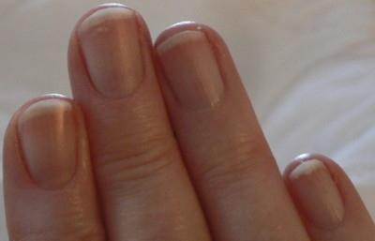
The white, crescent shaped part at the top of a nail.
- 3. Crepuscular Rays

Rays of sunlight coming from a certain point in the sky. Also known as “God's rays.”
- 4. Ferrule
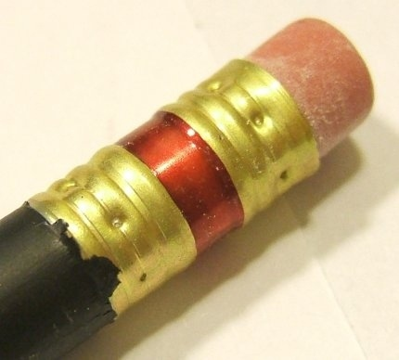
The metal part on a pencil.
- 5. Gynecomastia

Man-boobs.
- 6. Muntin

The strip separating window panes.
- 7. Morton's Toe
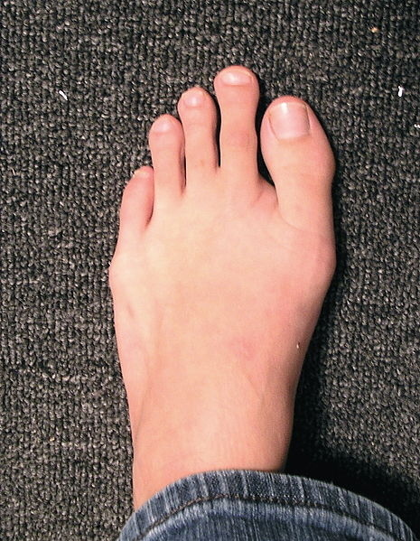
When your second toe is bigger than your big toe.
- 8. Arms Akimbo

Exactly what it looks like. Hands on your hips.
- 9. Desire Path

A path created by natural means, simply because it is the “shortest or most easily navigated” way.
- 10. Semantic Satiation
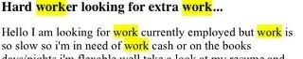
What happens when you say a word for so long that it loses its meaning. Limit limit limit limit limit limit limit limit limit.
- 11. Skeuomorph
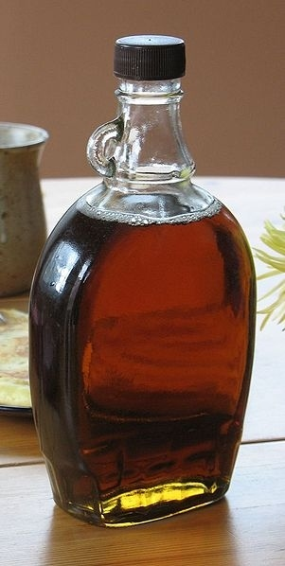
“A design feature copied from a similar artifact in another material, even when not functionally necessary.” For example, rivets on jeans, copper color on pennies, the shutter sound on a digital camera, and the pointless handle above.
- 12. Brannock Device
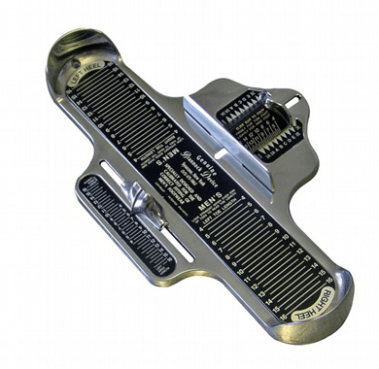
What is used to measure your feet at the shoe store.
- 13. Paresthesia
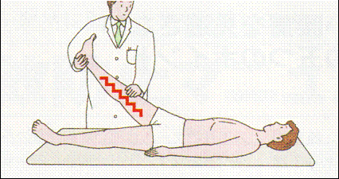
The pins and needles feeling you get when part of your body falls asleep. Bonus! This is known as obdormition.
- 14. Phosphenes
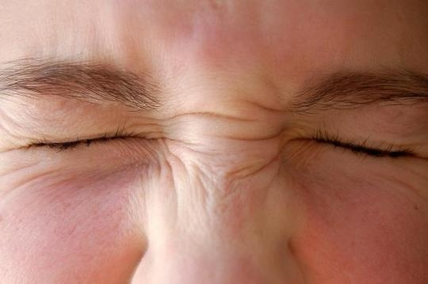
The lights you see when you close your eyes and press your hands to them.
- 15. Armscye
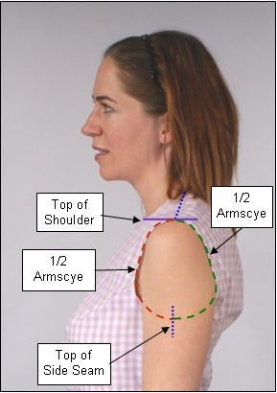
The armhole in most clothing.
- 16. Wamble

Stomach rumble.
- 17. Feat

A dangling piece of curly hair.
- 18. Peen
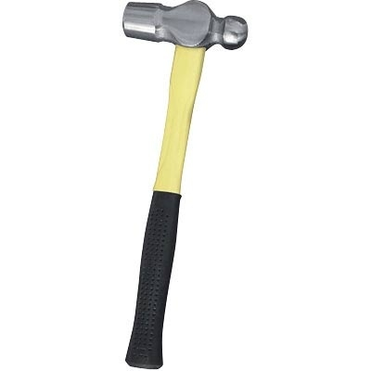
The side opposite the hammer's striking side.
- 19. Rectal Tenesmus
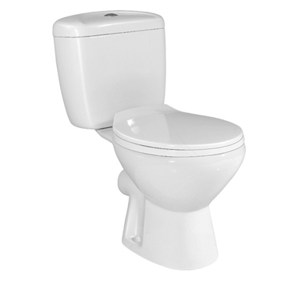
The feeling of incomplete defecation. We've all been there.
- 20. Dysania

The state of finding it hard to get out of the bed in the morning.
- 21. Mondegreen

Misheard lyrics.
- 22. Petrichor

The way it smells outside after rain.
- 23. Philtrum
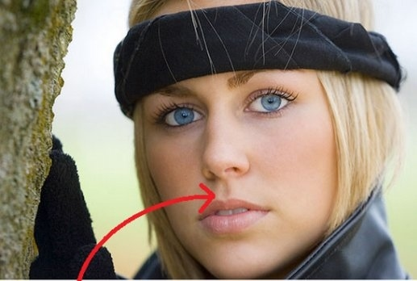
The groove located just below the nose and above the middle of the lips.
- 24. Purlicue
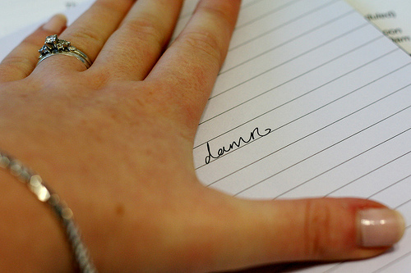
The space between the thumb and the forefingers.
- 25. Aglet
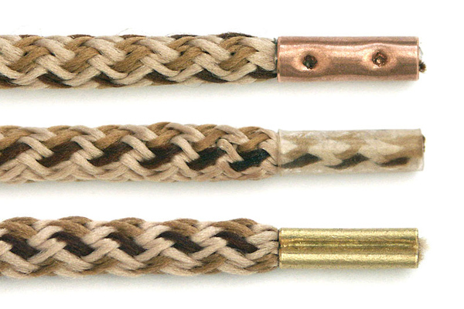
The plastic coating on a shoelace.
Share on Facebook

